**CI/CD pipeline with AWS code build**

**Services used:**

1. EC2
2. Code commit
3. Code build
4. Code Deploy
5. Code Pipeline
6. IAM
7. Git

**Code commit**

1. Create a repository in code commit
2. Clone that repository into the local machine
3. Create an HTML file

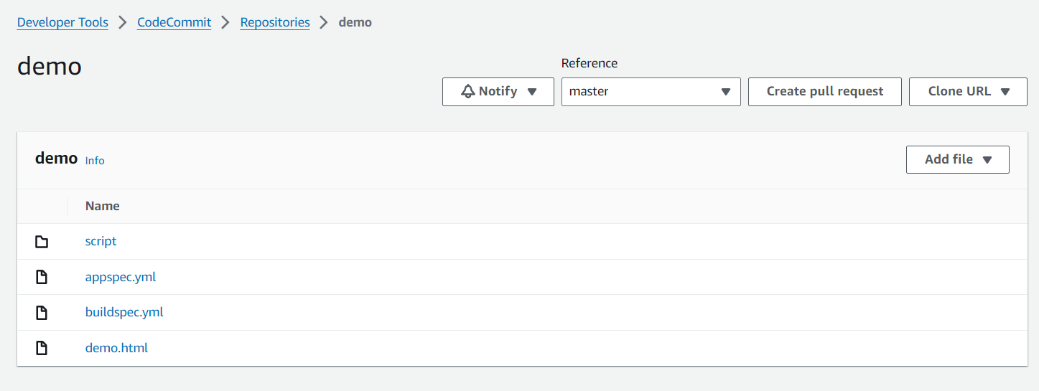

**Code build**

1. Create a new build
2. Create a new file buildspec.yml and push it in repo

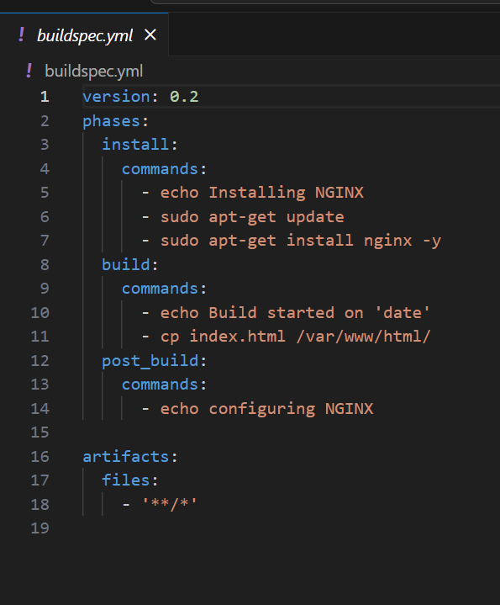

1. Now select the source as code commit and select the desired repo
2. Now mention the name of the buildspec file in code build configuration page
3. Select the environment as Ubuntu (as per buildspec and EC2)

**EC2**

1. Launch EC2 instance with Ubuntu image
2. Add IAM role for EC2 instance so that it can connect with code deploy

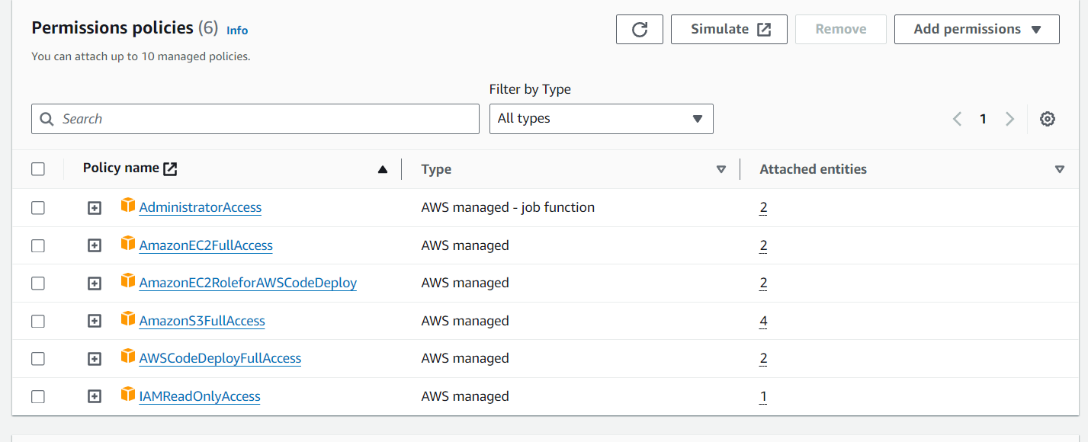

1. Now configuring EC2 instance for code deploy

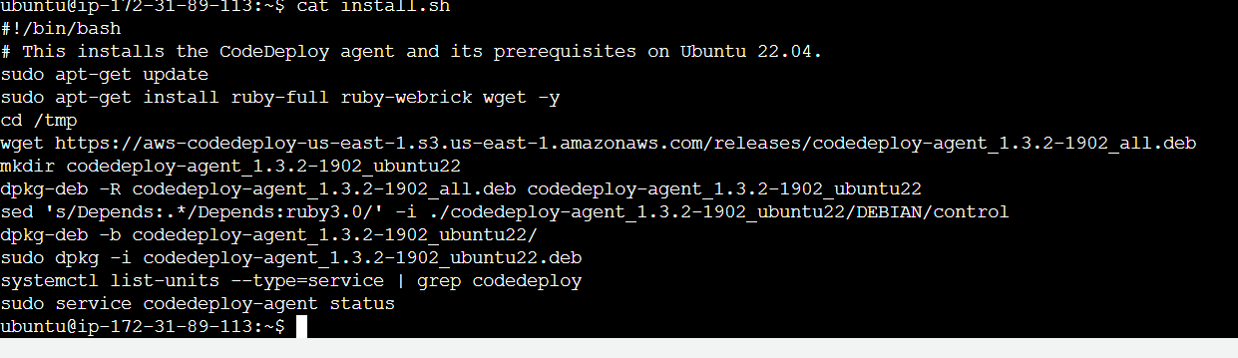

**Code deploy**

1. Create a deploy application and deployment group
2. Add another file appspec.yml and script folder

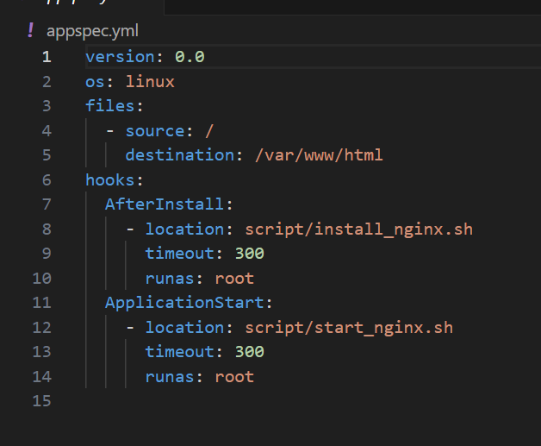

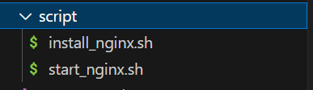

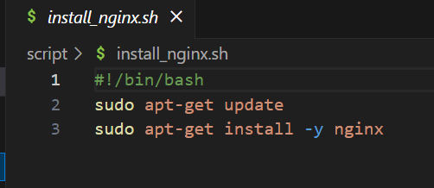

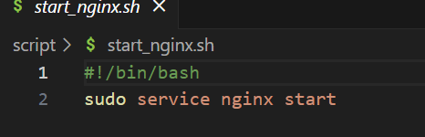

1. Select the EC2 instance for deployment

**Code Pipeline**

1. Add all the stages we have created and create a pipeline
2. Now to check whether our file is deployed or not we will copy the public IP and add /demo.html
3. Now when we commit any change our pipeline will automatically execute and deploy the changes

